**Add AWS RDS Targets to OEM**

Non Prod targets OEM URL: http://toem12cc.vodacom.corp:7788/em

Prod Targets OEM URL: http://poem12cc-slb.vodacom.corp/em

**Step1 Open AWS Inbound Ports**

Check if OEM and TNS ports (port 1521 and port 3872) were added to the RDS VPC Security Groups when the VPC for the Account was created. If not log a call to AWS Cloud Support to have this done:

* Cloud Support AWS [CloudSupportAWS@vodacom.co.za](mailto:CloudSupportAWS@vodacom.co.za) and
* Remedy Listener for AWS Support - Do Not Reply [AWSCloudSupport@vodacom.co.za](mailto:AWSCloudSupport@vodacom.co.za)

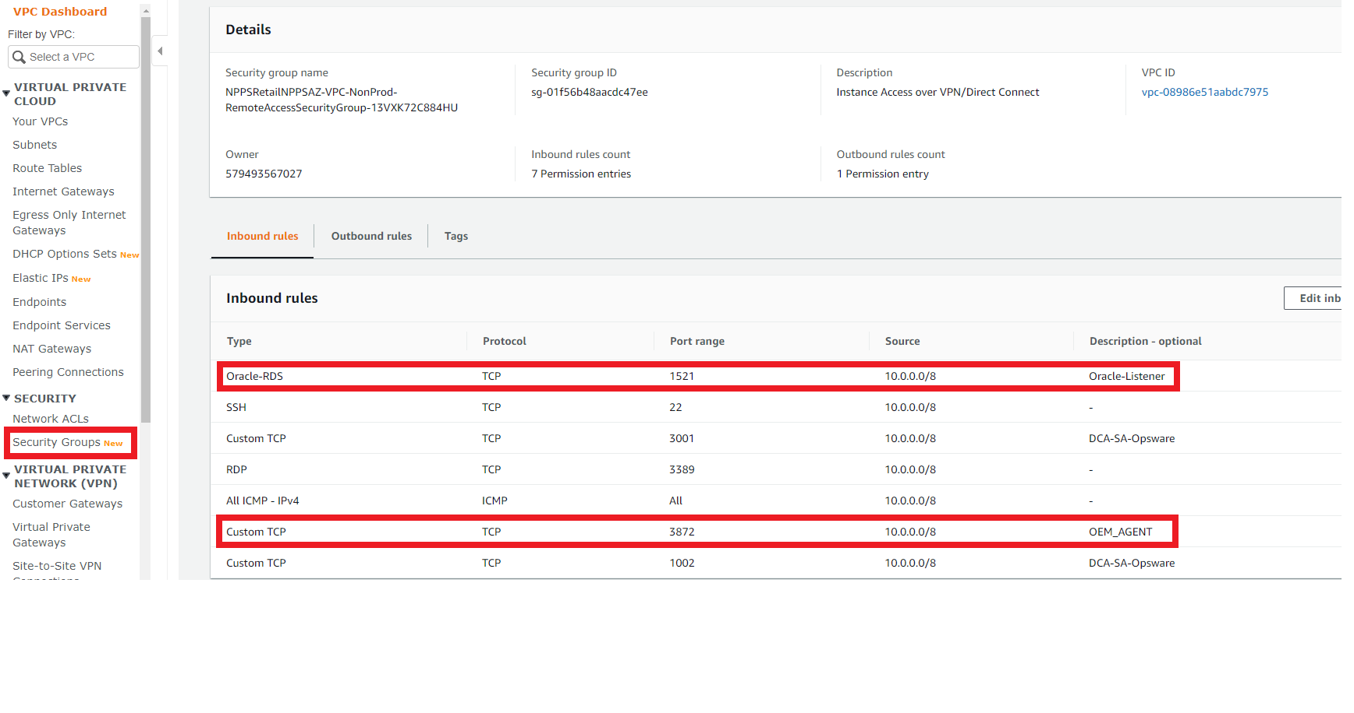

**Step2 Add OEM to Option Group and associate the option group with your DB instance.**

RDS Option Group for OEM: OEM_AGENT for OEM Cloud Control for 13c (<https://docs.aws.amazon.com/AmazonRDS/latest/UserGuide/Oracle.Options.OEMAgent.html>)

Version (AGENT_VERSION) -> 13.2.0.0.v3

Port (AGENT_PORT) -> 3872 (default)

OMS_HOST -> toem12cc.vodacom.corp (for non-prod) OR poem12cc-slb.vodacom.corp (for prod)

OMS_PORT -> 4900

AGENT_REGISTRATION_PASSWORD -> oraag3nt

ALLOW_TLS_ONLY-> false (default)

MINIMUM_TLS_VERSION -> TLSv1

TLS_CIPHER_SUITE -> No

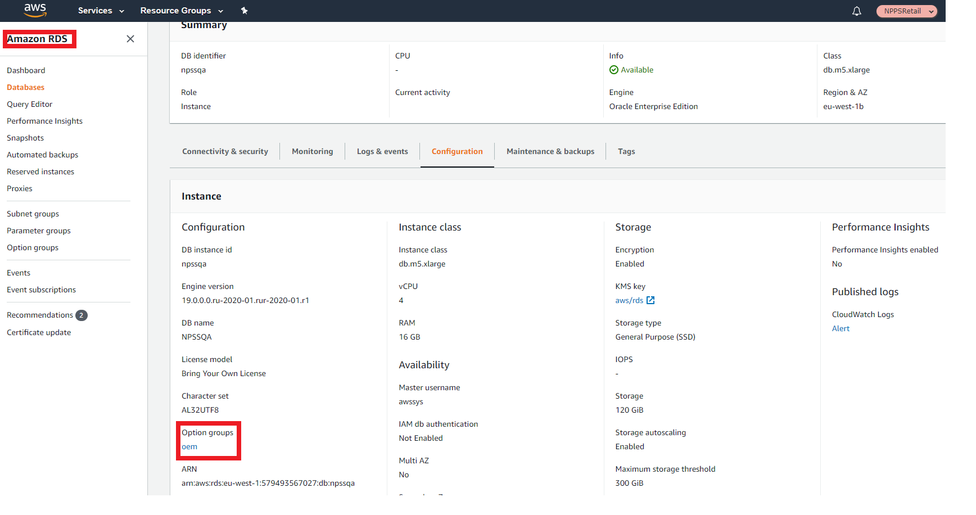

**Step3 OEM_AGENT info via SQL Developer**

You can use Amazon RDS procedures to run certain EMCTL commands on the Management Agent. Use SQL Developer to get required information:

ALTER USER dbsnmp IDENTIFIED BY AWSwelcome_123 ACCOUNT UNLOCK;

SELECT rdsadmin.rdsadmin_oem_agent_tasks.list_targets_oem_agent() as TASK_ID from DUAL; -> to get the TASK_ID, which will be used in the next query

SELECT text FROM table(rdsadmin.rds_file_util.read_text_file('BDUMP', 'dbtask-1591019795732-32.log')); -> to get the hostname to add to OEM

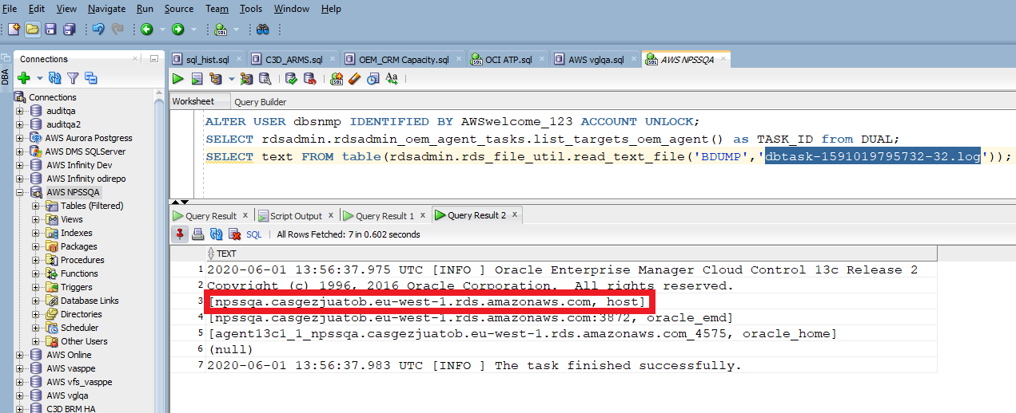

SELECT rdsadmin.rdsadmin_oem_agent_tasks.get_status_oem_agent() as TASK_ID from DUAL; -> to get the TASK_ID, which will be used in the next query

SELECT text FROM table(rdsadmin.rds_file_util.read_text_file('BDUMP','dbtask-1591020179538-32.log')); -> This procedure is equivalent to the emctl status agent command

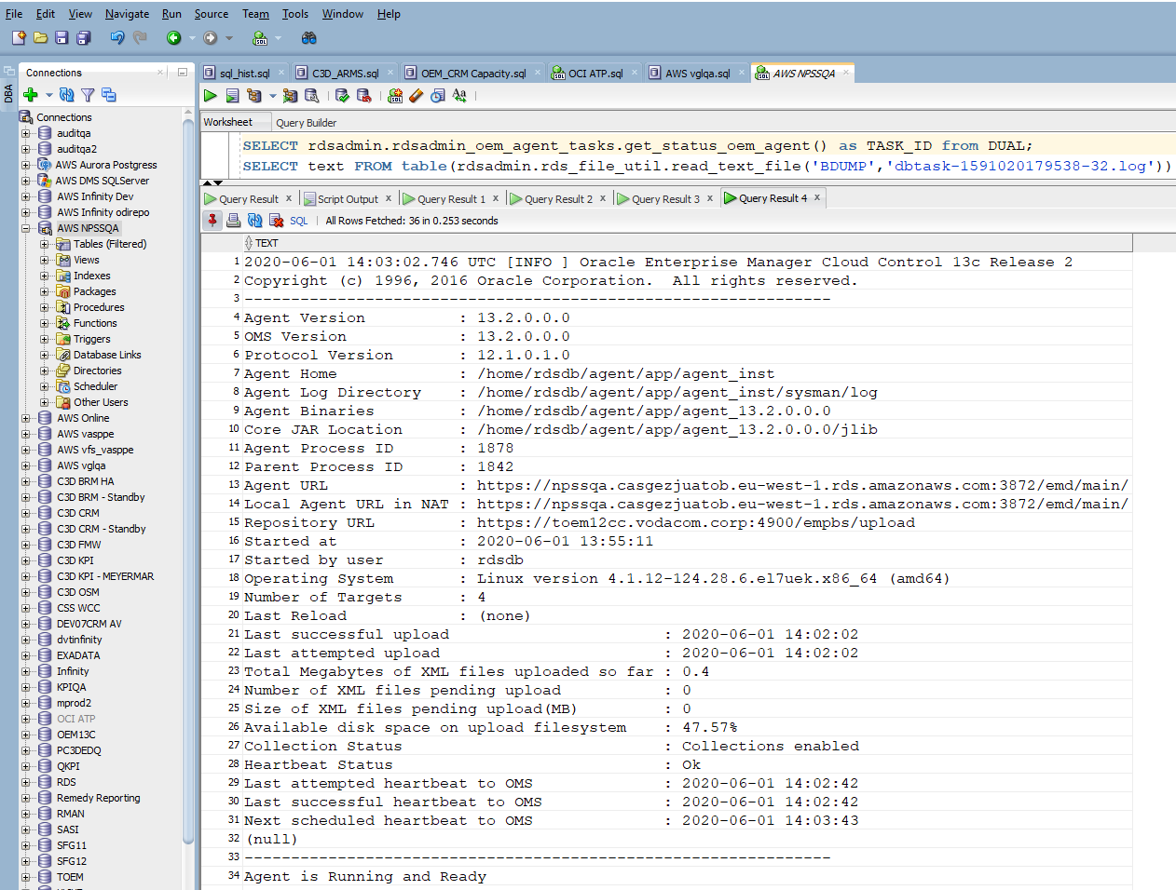

**Step4 Discover AWS RDS DB via OEM**

Autodiscovery is not supported. You must manually add database targets.

Add your targets to the OMS console manually:

* In your OMS console, choose Setup, Add Target, Add Targets Manually.
* Choose Add Targets Declaratively by Specifying Target Monitoring Properties.
* For Target Type, choose Database Instance.
* For Host, enter the host identifier from Step 2
* Click Add…

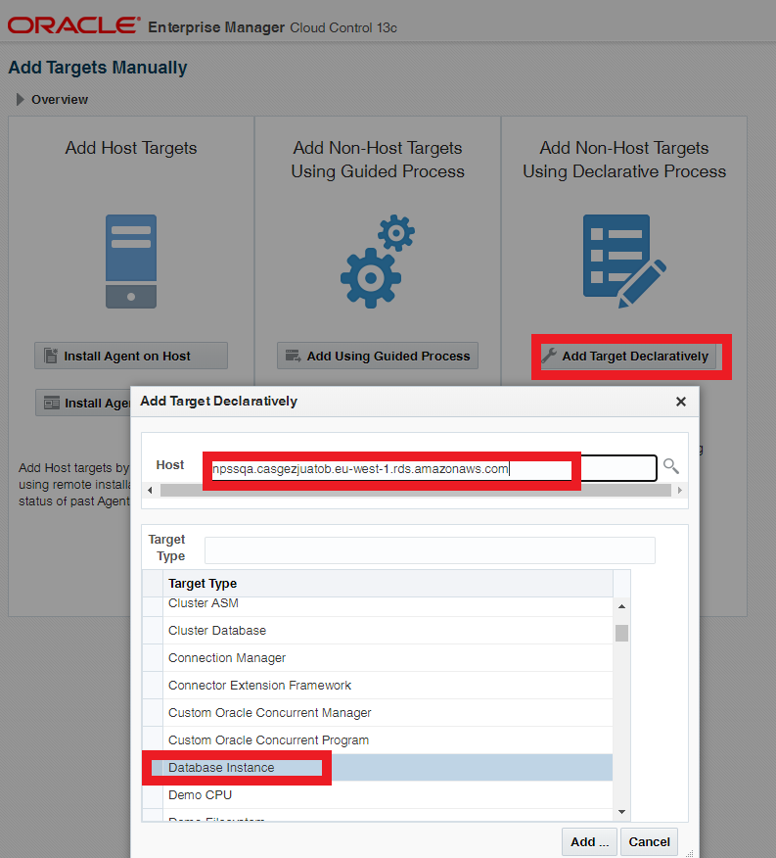

Specify the following database properties:

For Target name, enter a name.

For Database system name, enter a name.

For Monitor username, enter dbsnmp.

For Monitor password, enter the password from step 2 (AWSwelcome_123)

For Role, enter normal.

For Oracle home path, enter /oracle.

For Listener Machine name, the agent identifier already appears.

For Port, enter the database port. The RDS default port is 1521.

For Database name, enter the name of your database.

Choose Test Connection.

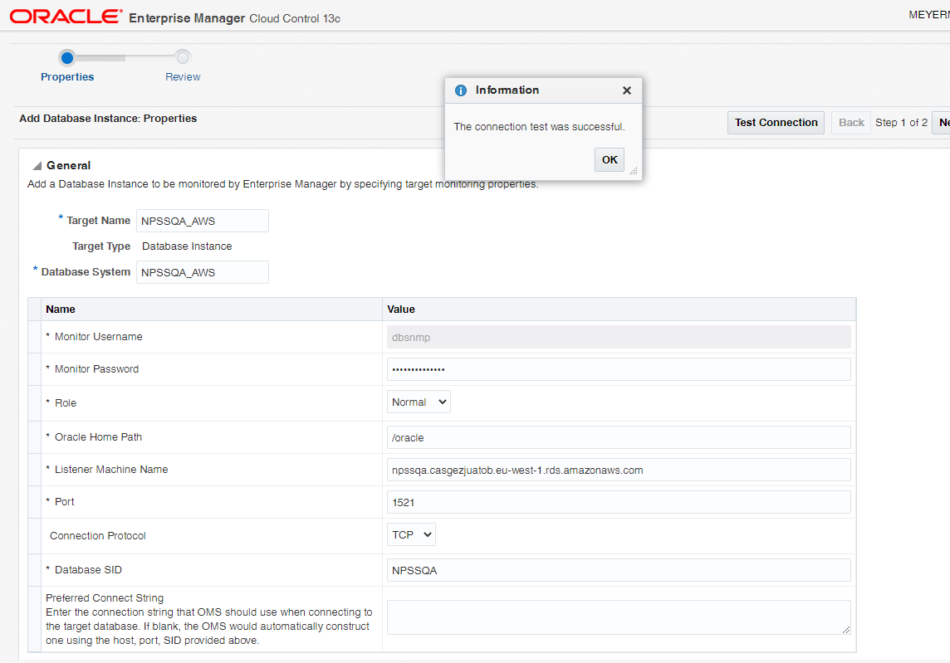

Choose Next.

Choose Submit.

You can now search for the target

The target database appears in your list of monitored resources.

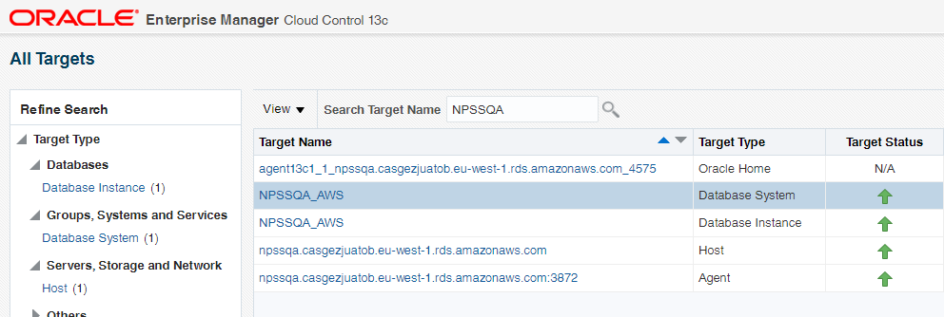

**Step5 Update Target Properties in OEM**



